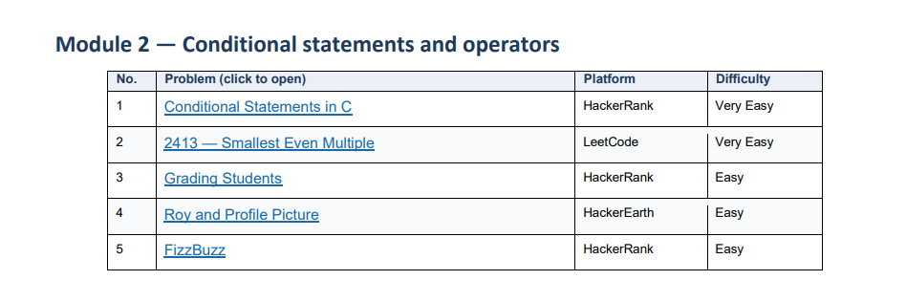

- Conditional Statements in C https://www.hackerrank.com/challenges/conditional-statements-in-c/problem
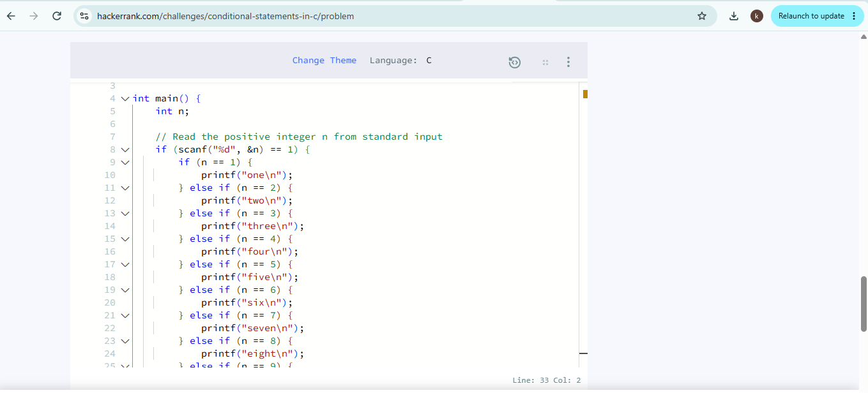
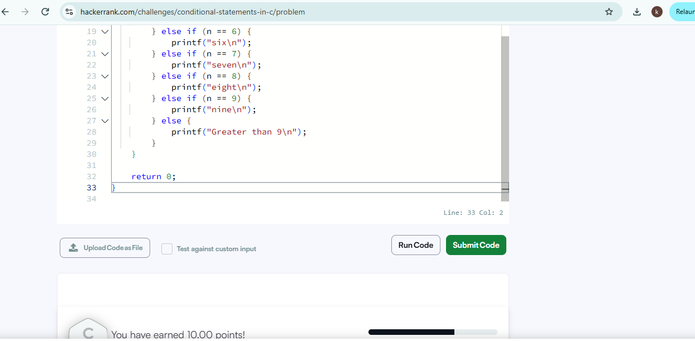
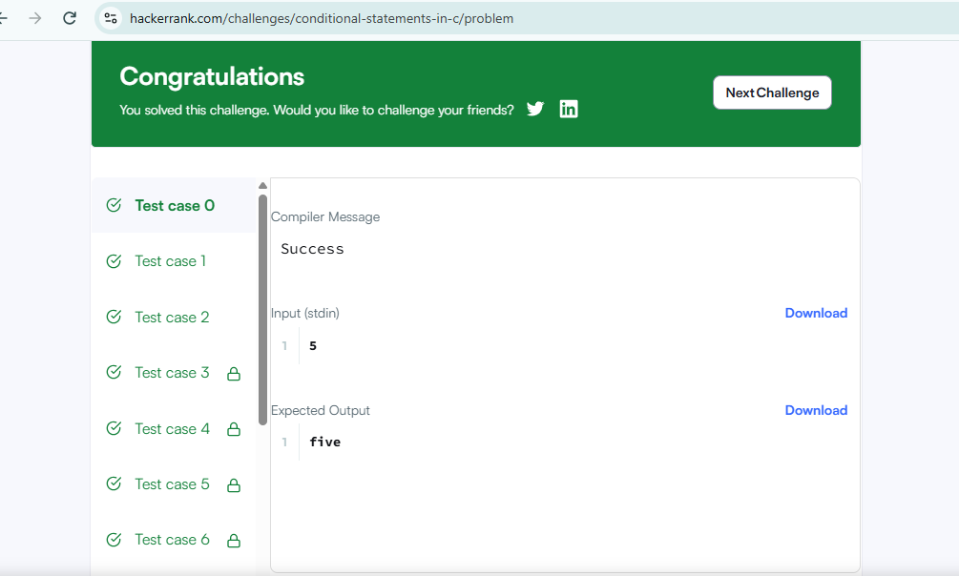

- Smallest Even multiple https://leetcode.com/problems/smallest-even-multiple/submissions/2191493061/
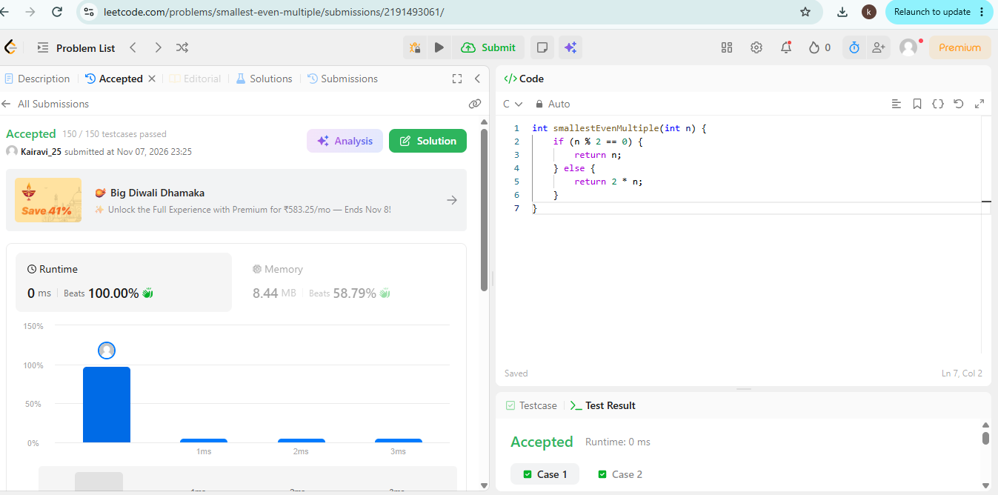

- Grading students https://www.hackerrank.com/challenges/grading/problem
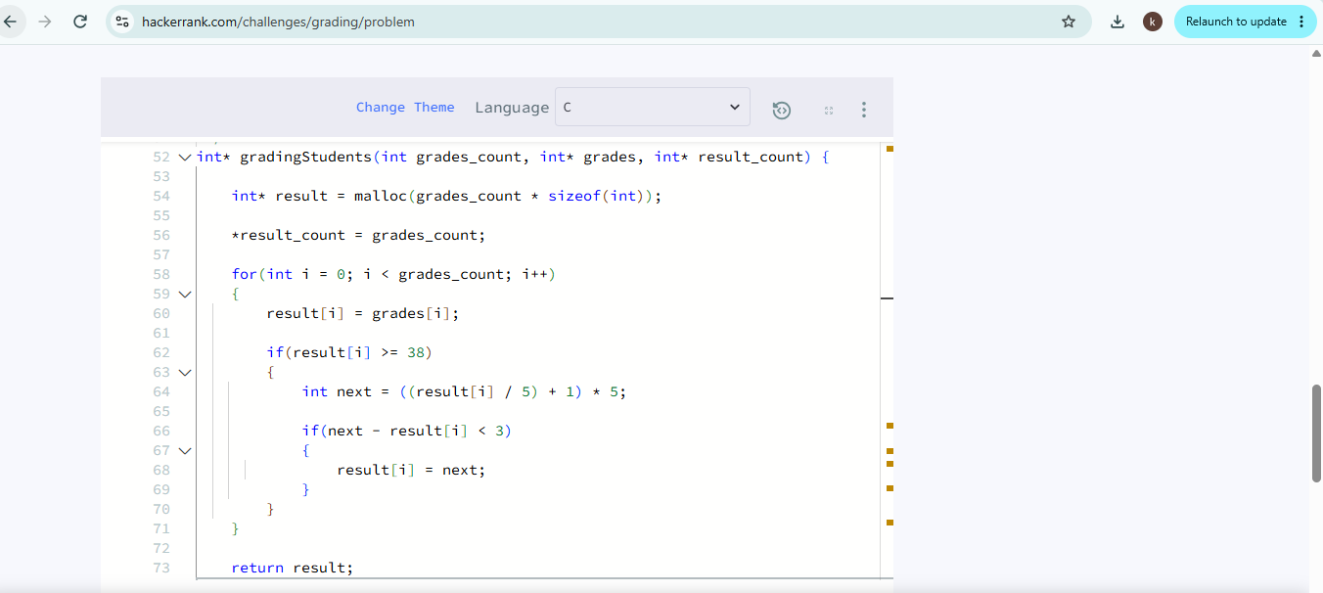

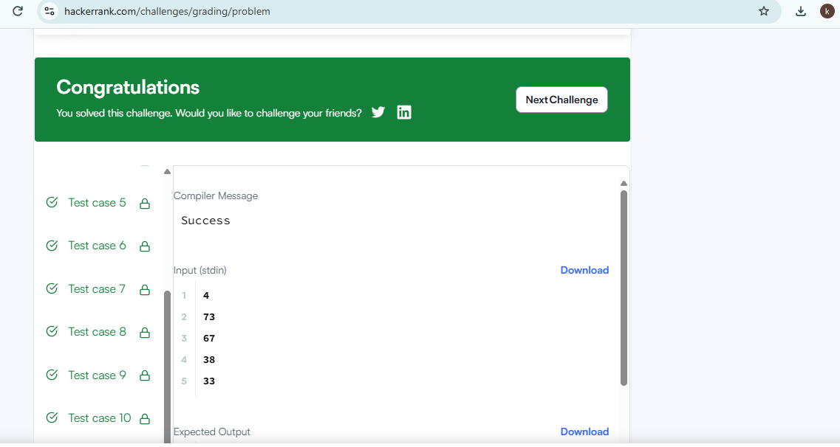

- Roy and Profile Picture https://www.hackerearth.com/practice/basic-programming/input-output/basics-of-input-output/practice-problems/algorithm/roy-and-profile-picture/
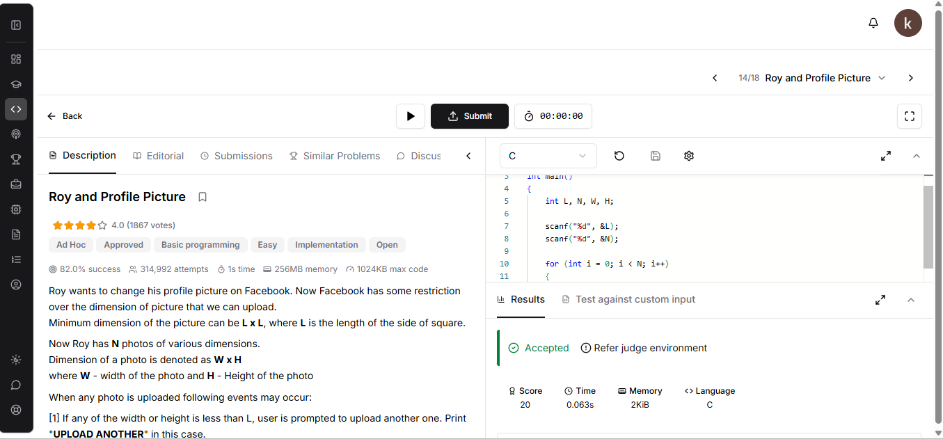

- Fizz Buzz https://www.hackerrank.com/challenges/fizzbuzz/problem


